The Quest for African American Citizenship in American History
Dr. Torren Gatson
Email:gatsont@wfu.edu
Phone: 302-463-8533
Class Time: Tuesday & Thursday 6pm - 9pm

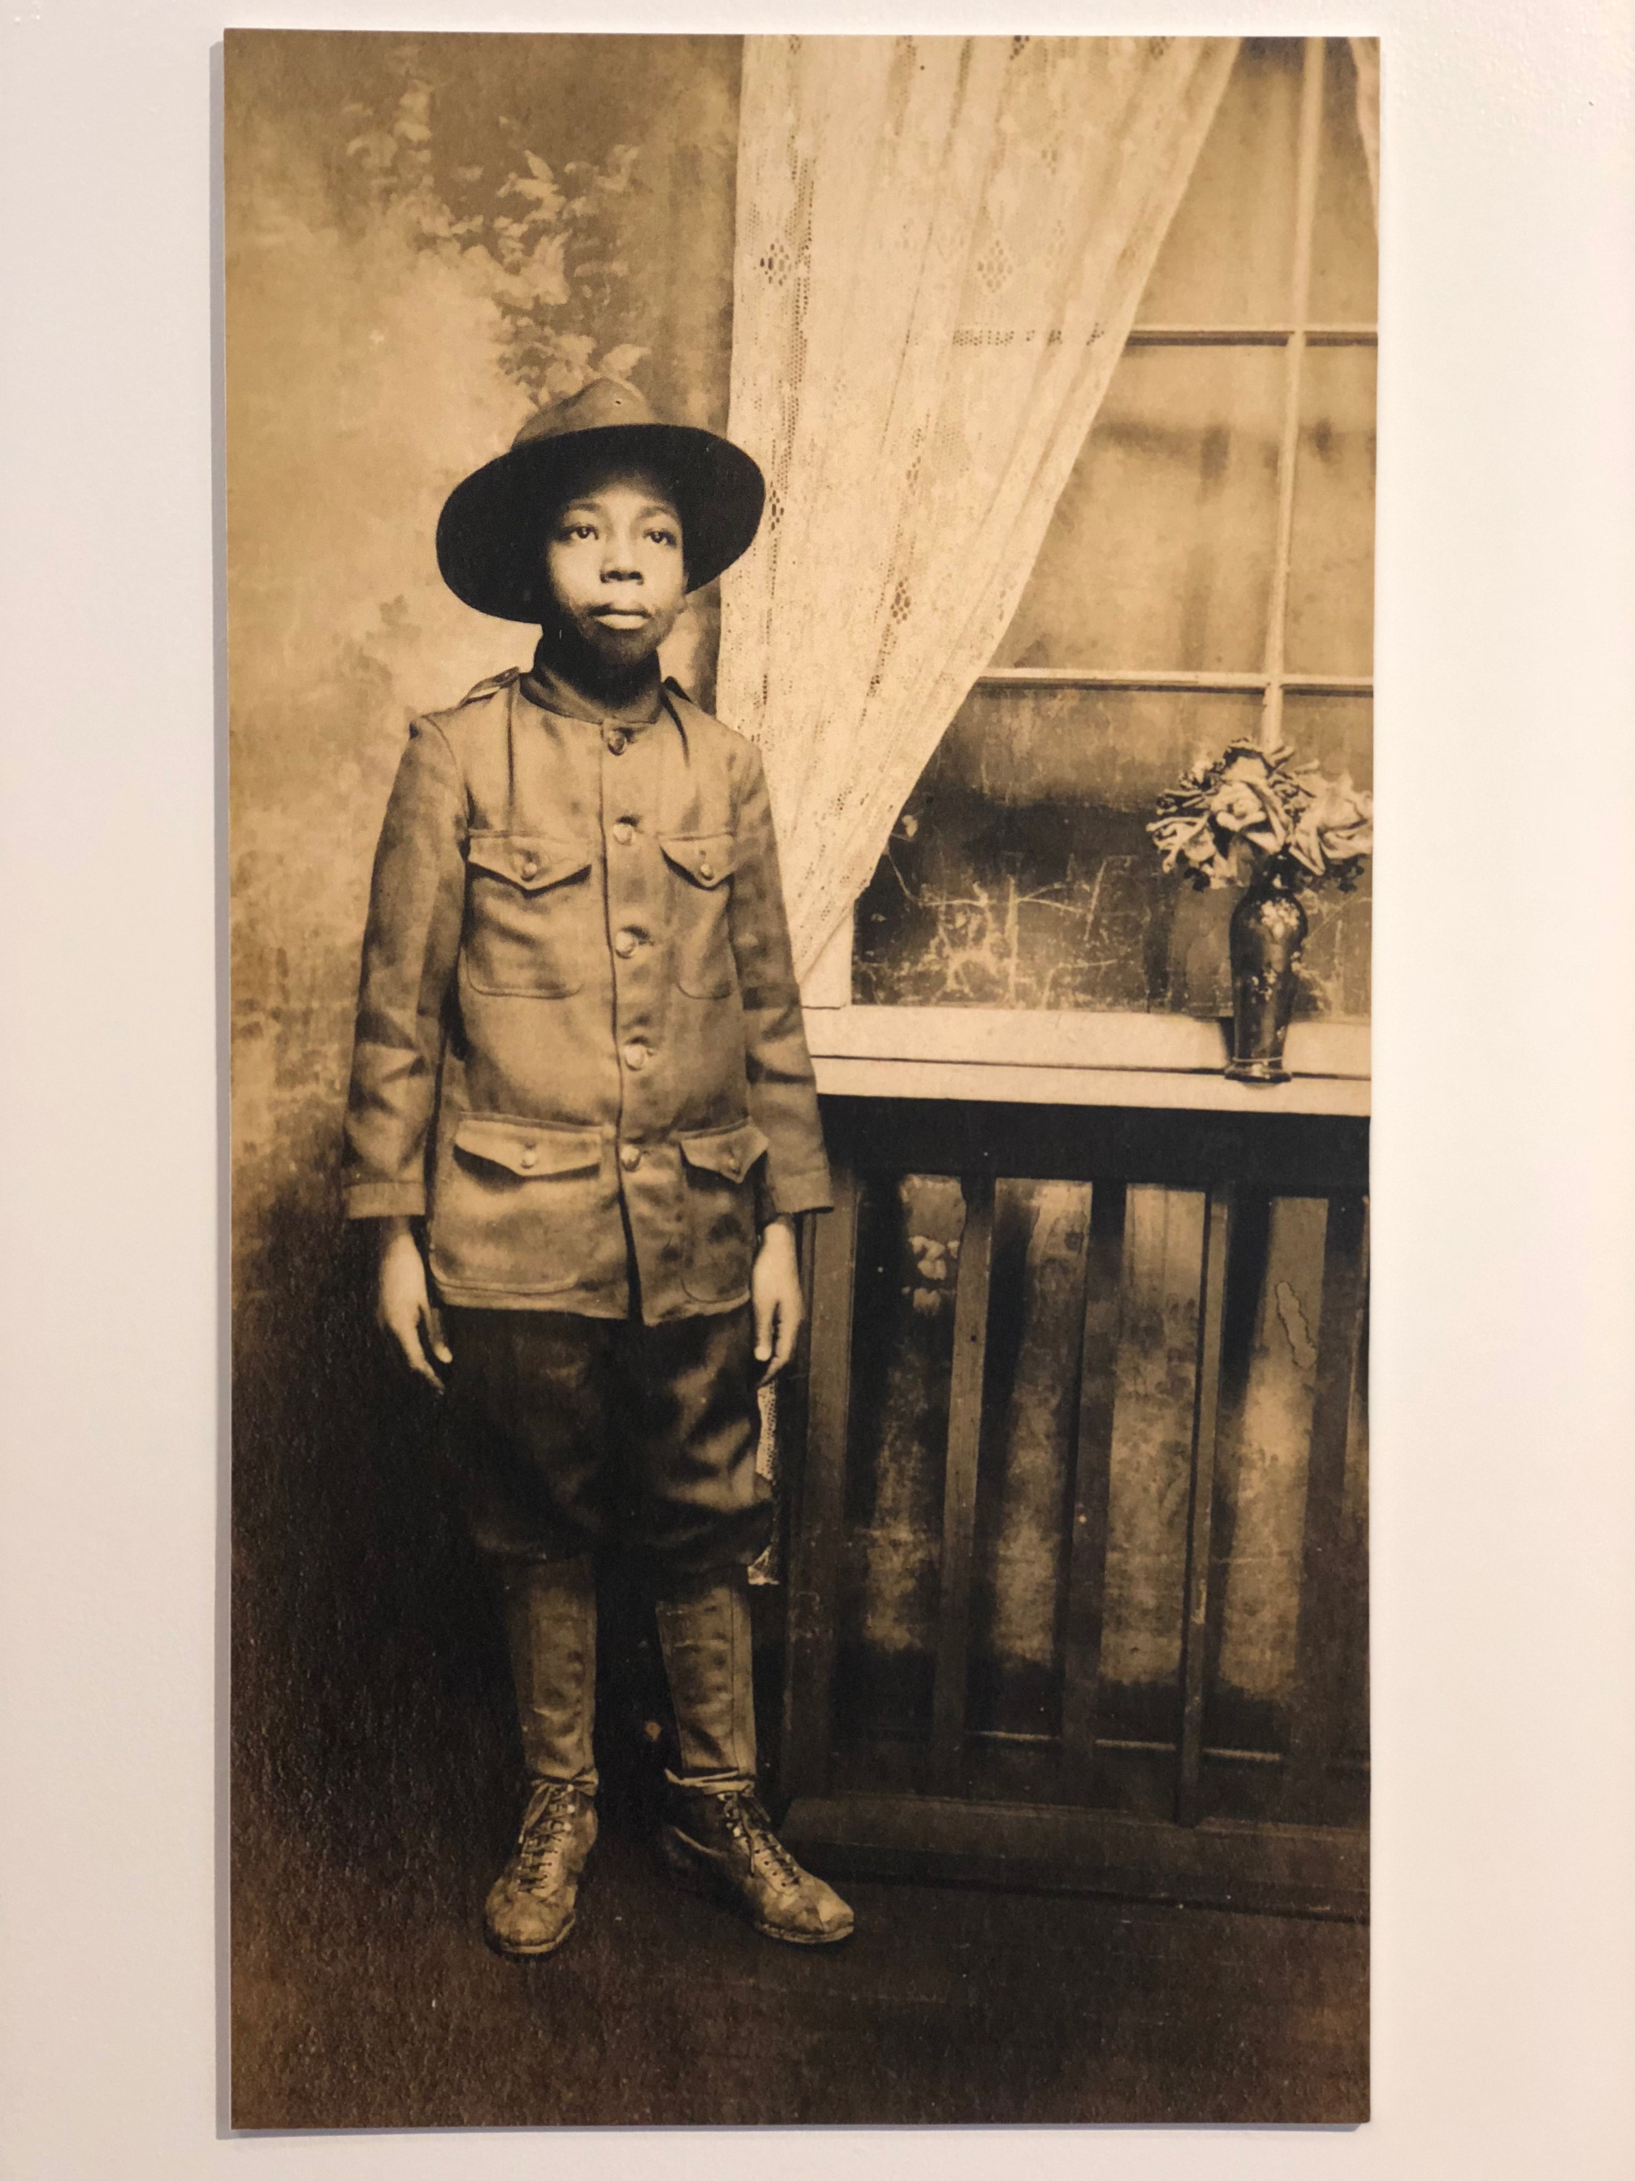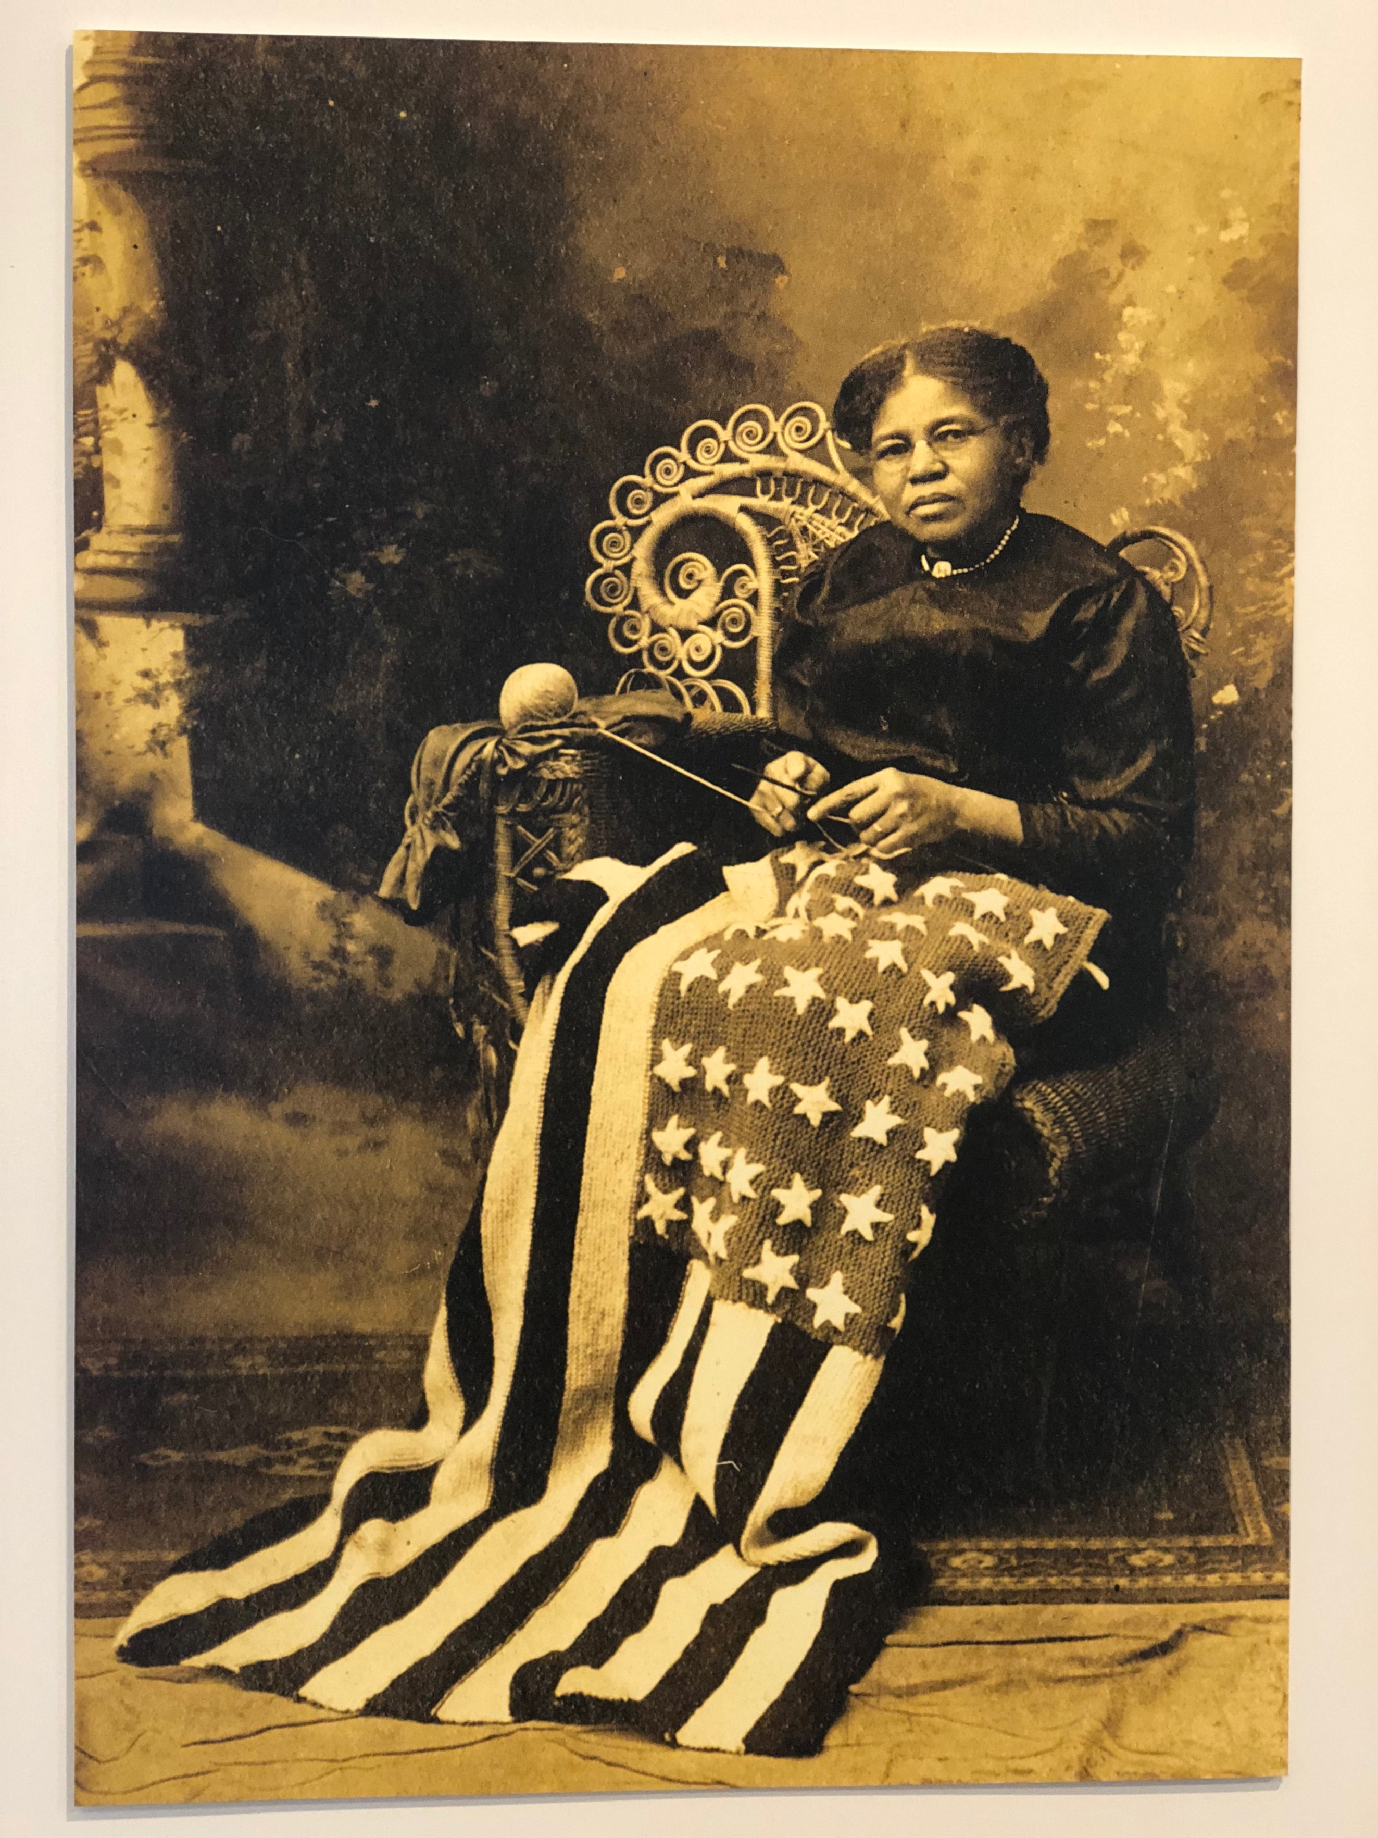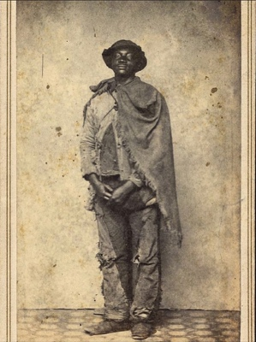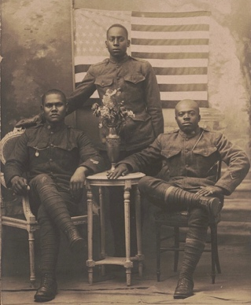

Course Description and Objectives
Covering the period of enslavement through the Black Freedom Struggle, this course hones in on key moments in American history that have shaped and crystallized African Americans quest for citizenship. This course will also expose students to history from a variety of different perspectives, methodologies and approaches. Students will analyze and evaluate scholarly work and position said works within the historiography through a series of class dialogue and reflective essays style papers.
American history is too vast a topic to cover every aspect of it from the creation of the colonies to the present. For this reason, our objective will be to focus on several major themes relevant to African American history throughout the semester. Each theme easily weaves into the conversation of citizenship. They are as follows:
- Traditional history and its counter arguments & historic conflicts: ethnicity, gender, race, class, and religion
- Slavery
- Emancipation
- Causes and consequences of the Civil War
- Emancipation & Reconstruction
- Black Freedom Struggle

Assigned Readings: The readings for the class will consist of a mixture of articles and potentially chapters from various books that speak to the varying themes within the course. Most readings will be provided. It will be each students responsibility to comprehend and master the prescribed readings.
Attendance and Late Policy: Attendance in class is mandatory. The door will close ten minutes after class starts. A graduate student can only succeed when they ae present and attentive classroom dialogue. While not a percentage of the final grade, attendance is also directly connected to participation. Once you arrive, you should be prepared to engage in class discussion.
Ethical scholarship Policies: The honesty, trustworthiness, and personal integrity of each student is integral to the life and purposes of the Wake Forest community. This statement is embodied in one of our oldest traditions, the honor system (The Honor Code). In signing an application for admission to Wake Forest, a student agrees to live by the honor system at Wake Forest. In specific terms that means that students have agreed not to deceive (lie to) any member of the community, not to steal from one another, not to cheat on academic work, not to plagiarize academic work, and not to engage in any other form of academic misconduct.

Special Needs
If you require accommodations for special learning needs, please do not hesitate to contact the Learning Assistance Center and Disabilities Services, click HERE for more information! I will be very receptive to any steps to help make your learning experience healthier and more successful.
Student Learning Outcomes:
Upon successful completion of this course, you will be able to:
- Interpret primary sources (including material culture, visual images, oral history, landscapes and others) for cultural and historical meanings.
- Analyze written secondary sources thoughtfully, with attention to argument and point of view.
- Analyze public interpretations of the past—including exhibitions, historic sites, and monuments—with attention to argument, point of view, and historical context.
- Create original interpretations of the past that engage public audiences.
- To write clearly and persuasively.
- Speak with passion, clarity, and respect over various historical themes.
Teaching Methods:
This course employs classroom discussion to attain collective exploration of historical perspectives. While primarily set in a seminar style, in addition to learning a body of historical content, we will be exploring how to “read” a variety of cultural texts to glean historical insights. In every class period, time will be reserved for consideration of historical documents, photographic images, music, or video. In some cases, students will form smaller groups in the classroom to consider a question, an article excerpt, or a primary source.
Course Requirements:
- Reader responses: 40%
Each week, you will write a response to the weeks readings and or documents, to assess your comprehension of the materials your responses must be at least 4 typed pages. These readings will be a combination of a primary source documents and/or second source readings.

- Seminar discussion 20%
Each Student will lead or co-lead one class discussion is expected to engage their peers in an interactive learning exercises.

- Final paper (Due last day of class) 40%
Students will write a 15 to 20 page paper examining the ideal of “Citizenship” as it relates to African Americans in America. Students will use the various course readings and primary documents to clearly articulate and answer the following questions:

  - If African Americans ever truly received full exercise of the rights of citizenship.
  - Compare and contrast a historical document of either human or civil rights for African Americans with current event of American political, social, or religious connection. (as they relate to persons of color)
  - Create an argument around use of the word “citizenship” and if it best represents The African American experience in America.

Required Text:

Readings for this course will be delivered directly to you

Course Calendar:

Week 1
July 7th Brief course overview and review of syllabus

July 9th Slavery and the Constitutional Convention: Historical perspectives. (1787), David Walkers Appeal and the African American perspective of slavery and America. (1829)

Week 2
July 14th Living Free in Fear: examining the Fugitive Slave Act and its impact, meaning and ramifications on free people of color. (1850), Frederick Douglass, “What of the Negro and the 4th of July.” (1852)

July 16th Charles Lenox Remond, “An Anti-Slavery Discourse.” (1857), Amendment to the United States Constitution and responses by Jamal Greene and Jennifer Mason McAward. (1865)

Week 3
July 21st Unpacking the 14th Amendment to the united Stated Constitution, Booker T. Washington, “Atlanta Exposition,” examining reconstruction and the false promise of a new America. (1895)

July 23rd I, Too, Am America. Framing African American identity during the early twentieth century,

Week 4
July 28th Martin Luther King “Letter from a Birmingham Jail.” (1963),
John Lewis “Original drafted Speech on behalf of SNCC.” (March on Washington, 1963)
July 30th Freedom School students, Palmers crossing (Declaration of Independence) Hattiesburg, Mississippi. (1964), Fannie Lou Hammer “Say it Plain” speech at Democratic National Convention (DNC) (1964)
Week 5
August 4th Stokely Carmichael “Call for Black Power” (1966), Will the fight? Should They Fight? African Americans in Time of War.
August 6th They tell me I am a citizen, but I Can’t Vote! (Voting Rights Act of 1965), A House is not a Home: home ownership and African American Identity
Week 6
August 11th Stranger at Home…James Baldwin and what it means to be an American (We will watch the film I am not your Negro
August 13th Final Paper Due

*Any required papers are due at the beginning of class*
**Any information found within this syllabus (i.e. assignments, due dates or instructions) is subject to change at the discretion of the professor**

